Forward Propulsion Using Ionic Thruster

Submitted by
Md. Iftakhar Jaman Rahat (210011243)
Chowdhury Tahsin Al Mamun (210011214)
Mehdi Hasan (210011253)
Sadman Sad Mugdho (210011262)
Rafid Raihan Adib (210011264)
Md. Rakib Mahmud (210011285)



CAPSTONE DESIGN II (ME/IPE 4710) [Group B03]
DEPARTMENT OF MECHANICAL AND PRODUCTION ENGINEERING
ISLAMIC UNIVERSITY OF TECHNOLOGY (IUT)

March 2026

EXECUTIVE SUMMARY
This report presents the design, simulation, fabrication, and experimental testing of a three-stage ionic thruster developed as part of the Capstone Design II project at the Islamic University of Technology (IUT). The project, titled Forward Propulsion Using Ionic Thruster, investigates the practical generation of thrust through ion acceleration — a concept rooted in electrohydrodynamic (EHD) fluid mechanics.
Conventional propulsion systems rely on combustion or rotating machinery, introducing mechanical complexity, acoustic noise, and high energy consumption. Ionic thrusters generate propulsive force through the movement of electrically charged ions in an electric field, producing silent, flameless airflow with no moving parts. Although ionic thrusters are well established in spacecraft propulsion, their adaptation for low-power, ground-level applications remains an active research frontier.
The project objectives were to design and fabricate a three-stage ionic thruster, simulate its electromagnetic and fluid-dynamic behavior using COMSOL Multiphysics and ANSYS Fluent, and experimentally verify thrust production within a total budget of BDT 15,200. Simulations confirmed ion generation, electric field distribution, and resultant airflow patterns consistent with EHD theory. The physical prototype was assembled using aluminum electrodes, a high-voltage DC power supply, and an acrylic support frame.
Experimental testing demonstrated that the prototype produced sufficient ionic wind to extinguish two to three simultaneously lit candles placed in the downstream airflow, providing qualitative verification of thrust generation consistent with simulation-predicted exit velocities of 1.8–2.4 m/s. The findings establish the feasibility of multi-stage ionic thrust at prototype scale and open pathways toward applications in silent cooling, low-power drones, and propulsion education. Recommendations are provided for incorporating quantitative thrust measurement instruments and precision electrode fabrication in future iterations.

ACKNOWLEDGEMENTS
The authors sincerely thank the Department of Mechanical and Production Engineering at Islamic University of Technology (IUT) for providing the academic framework and resources necessary for this capstone project. Heartfelt gratitude is extended to our project supervisor for invaluable guidance, technical mentorship, and constructive feedback throughout all project phases.
We acknowledge the laboratory staff and technicians who assisted in prototype fabrication. Their practical expertise greatly facilitated the manufacturing process. We also acknowledge the financial support provided within the capstone design course framework, which enabled procurement of all required materials and components within the allocated budget of BDT 15,200.
Finally, we thank our fellow students and colleagues for their encouragement and collaborative spirit throughout the duration of this project.

MAPPING OF ASSESSMENT, COs TO POs

ASSESSMENT | CO | PO1 | PO2 | PO3 | PO4 | PO5 | PO6 | PO7 | PO8 | PO9 | PO10 | PO11 | PO12
Eng. Knowledge Application | CO1 | 1.1, 3.1
Problem ID & Analysis | CO2 |  | 2.1, 2.3
Design & Development of Solutions | CO3 |  |  | 3.1, 3.2
Research and Investigation | CO4 |  |  |  | 2.1, 7.4
Modern Tools Application | CO5 |  |  |  |  | 3.5, 5.1
Safety & Contextual Reasoning | CO6 |  |  |  |  |  | 9.1
Sustainability & Env. Impact | CO7 |  |  |  |  |  |  | 8.1
Ethics & Professional Responsibility | CO8 |  |  |  |  |  |  |  | 9.2
Teamwork and Leadership | CO9 |  |  |  |  |  |  |  |  | 10.2
Effective Communication | CO10 |  |  |  |  |  |  |  |  |  | Exec. Summary
Project Management | CO11 |  |  |  |  |  |  |  |  |  |  | 10.4
Lifelong Learning | CO12 |  |  |  |  |  |  |  |  |  |  |  | 12.2
Table 1. Mapping of Assessment, COs to POs

TABLE OF CONTENTS

EXECUTIVE SUMMARY i
ACKNOWLEDGEMENTS ii
MAPPING OF ASSESSMENT, COs TO POs iii
TABLE OF CONTENTS iv
List Of Figures vi
List Of Tables vii
CHAPTER 1: INTRODUCTION 1
1.1 Background and Motivation 1
1.2 Problem Statement 1
1.3 Project Objectives 2
1.4 Scope of the Project 2
1.5 Report Organization 2
CHAPTER 2: LITERATURE REVIEW 3
2.1 Review of Existing Solutions 3
2.2 Relevant Technologies and Methods 3
2.3 Gaps in Current Knowledge 4
2.4 Summary of Findings 4
CHAPTER 3: SYSTEM DESIGN AND METHODOLOGY 5
3.1 Design Requirements and Specifications 5
3.2 Conceptual Design 5
3.3 Final Design Selection 6
3.4 Design Analysis and Calculations 6
3.5 Tools and Techniques Used 6
CHAPTER 4: COMPONENT SELECTION AND MATERIALS 8
4.1 Criteria for Component Selection 8
4.2 Materials Used 8
4.3 Cost Analysis and Budget 8
4.4 Sourcing of Components 9
CHAPTER 5: MODELING AND SIMULATION 10
5.1 Simulation Software and Tools 10
5.2 Model Development 10
5.3 Simulation Results and Analysis 11
5.4 Design Optimization 13
CHAPTER 6: PROTOTYPE DEVELOPMENT 14
6.1 Assembly Process 14
6.2 Challenges During Fabrication 14
6.3 Testing Procedures and Setup 15
CHAPTER 7: EXPERIMENTAL TESTING AND RESULTS 16
7.1 Testing Objectives 16
7.2 Test Plan and Protocol 16
7.3 Data Collection 17
7.4 Analysis of Results 17
7.5 Comparison with Design Specifications 17
CHAPTER 8: SUSTAINABILITY AND ENVIRONMENTAL IMPACT 18
8.1 Energy Efficiency Analysis 18
8.2 Environmental Impact Assesment 18
8.3 Sustainable Practices and Recommendations 18
CHAPTER 9: SAFETY, ETHICS, AND PROFESSIONAL RESPONSIBILITY 19
9.1 Safety Consideration in Design and Operation 19
9.2 Ethical Consideration in Project Execuion 19
9.3 Compliance with Industry Standards and Regulations 19
CHAPTER 10: PROJECT MANAGEMENT AND TEAM COLLABORATION 20
10.1 Project Planning and Timeline 20
10.2 Task Allocation and Responsivities; 20
10.3 Team Communication and Coordinaiton 20
10.4 Budget and Resource managemnet 21
CHAPTER 11: DISCUSSION 22
11.1 Interpretation of Results 22
11.2 Lessons Learned; 22
11.3 Limitations of the project 22
11.4 Potential Improvements 23
CHAPTER 12: CONCLUSIONS AND RECOMMENDATIONS 24
12.1 Summary of Key Findings 24
12.2 Recommendations of Future Work 24
12.3 Impact of the Project Outcomes 25
REFERENCES 26
APPENDICES 28
A. Additional Figures and Tables 28
B. User Manual and Operational Guide 28
C. Raw Data from Experiment 29
D. Relevant Standers and Codes 29
E. Course Outcomes 29

LIST OF FIGURES
Figure 1. Model Developed in Ansys Fluent 10
Figure 2. 1D Force VS Thrust Simulation 11
Figure 3. 2D Force VS Thrust Simulation 12
Figure 4. Velocity VS Voltage Simulation 12
Figure 5. Final Assembly 14

LIST OF TABLES
Table 1. Mapping of Assessment, COs to POs iii
Table 2. Design Specifications and Requirements 5
Table 3. Bill of Materials and Cost Breakdown 8
Table 4. Candle Extinction Test Results 16
Table 5. Project Timeline and Milestones 20

CHAPTER 1: INTRODUCTION
This chapter provides the background of the capstone project. It presents the idea of the ionic propulsion, remarks the engineering problem the project is dealing with, reports the project goals and describes the scope and the plan of the report. The chapter tackles the Course Outcomes CO2 and CO3 by defining an intricate engineering issue and presenting a suitable response to design.

1.1 Background and Motivation
Traditional mechanical propulsion methods, such as turbofans, propellers, internal combustion engines, etc. are based on rotating or reciprocating equipment to produce thrust by moving fluid masses. These systems impose considerable problems such as mechanical vibration, acoustic noises and thermal losses and complicated maintenance needs.
With the world moving towards cleaner, quieter and more efficient propulsion systems, alternative propulsion paradigms have attracted a lot of research attention. Ionic thrusters (also called electric hydrodynamic (EHD) thrusters or ion wind devices) capitalize on the transport of ions of opposite polarity in a neutral gas to create a net fluid momentum ionic wind generating propulsion without any moving parts. This is based on the physics of corona discharge, with Brown having formally studied the working principle as early as 1928 [1], and subsequently the ion engines have been used extensively in space propulsion, where they are used to drive deep-space missions in space due to their large specific impulse and low fuel consumption [2].
Ionically powered heavier-than-air flight (controlling the heavier-than-air atmospheric circulation) was demonstrated sustained in a pioneering study published in 2018 in Nature by Xu et al. [3] and catalyzed growing interest in EHD propulsion as a ground-level use was stimulated. The inspiration behind this project came in the disparity between theoretical possibility of ionic propulsion on the one hand and feasible multi-staged application at a prototype level on the other hand in an academic capstone setting. This project provides research contributions to the empirical body of knowledge of EHD propulsion systems by developing, simulating, and building a three-stage ionic thruster.

1.2 Problem Statement
The theoretical benefits of ionic propulsion are limited, though, by very poor thrust-to-power ratios at small sizes, and a limited comprehension of multi-stage electrode designs. Current single-stage ionic propulsion systems produce millinewtons of propulsion, which is not adequate in most applications. Multi-stage designs can enhance ionic wind by accelerating ions in sequence, however design variables of inter-stage spacing, electrode geometry, and voltages distributions are not adequately studied to date in low-cost prototype designs. Moreover, such computational tools as the COMSOL Multiphysics and ANSYS Fluent rarely have been used together in capstone-level ionic thruster research to compare the results of electromagnetic and fluid-dynamic simulations. This is a project which puts the two gaps together in the form of integrated dual platform simulation and physical prototype testing.

1.3 Project Objectives
The main goals of the present project are as follows: To develop a three stage ionic thruster whose emitter to collector electrode separation will be optimised to generate the maximum ionic wind. To model the electric distribution of the field, ion transport and consequent airflow with the help of COMSOL Multiphysics and ANSYS Fluent. In order to create a physical prototype of an ionic thruster of three stages with a total cost of BDT 15,200.
In a qualitative experimental validation of the thrust output of the prototype, it was necessary to prove the existence of an ionic wind strong enough to put out open-flame candles. To measure the sustainability and safety, as well as ethical aspects of ionic propulsion systems.

1.4 Scope of the Project
The proposed project will involve the design, simulation and physical prototyping of a three stage ionic thruster as a prototype propulsion system. The experiment involves electromagnetic and fluid-dynamic modeling, printing of electrodes made of locally produced aluminum and acrylic frame, and qualitative testing of the experiment by candle flame extinction as a proxy of an airflow. The project excludes the quantitative measurement of thrust by load cells or thrust balances, the space propulsion optimization and the scaling up to flight capable configurations. The experiment was done in a controlled laboratory condition. Budget limitation of BDT 15,200 constrained the choice of components and went against accurate instrumentation.

1.5 Report Organization
In chapter 2, the literature on the relevant topics of ionic propulsion and EHD basics are reviewed. The system design methodology is described in Chapter 3. Chapter 4 is an introduction to component selection and cost analysis. Chapter 5 outlines the modeling and simulation model and findings. Prototyping is recorded in chapter 6. In chapter 7, there are experimental results. Chapters 8 and 9 concern sustainability, safety and ethics. In chapter 10, there is project management. Chapters 11 and 12 discuss, conclude and give recommendations.

CHAPTER 2: LITERATURE REVIEW
The chapter is a critical review of available literature in the fields of ionic propulsion, EHD fluid mechanics and multi-stage thruster design. It covers CO4 and CO12 since the project is based on the existing engineering literature and it reveals knowledge gaps that support the ongoing work.

2.1 Review of Existing Solutions
Ionic wind, which is the transport of the neutral gas molecules by the electrically accelerated ions, was a phenomenon that has been known since the start of the twentieth century. The original patent by Brown [1] in 1928 explained how generator could be made using electrostatic fields to generate thrust and later experimental researchers validated that the process was repeatable and could be scaled. The first uses have been mostly electrostatic precipitators that utilize the ionic wind to eliminate particulate matter in industrial exhaust gas [4]. Gridded ion engines have become commercially viable in spacecraft propulsion. The NASA Dawn and Hayabusa2 missions employed xenon based gridded ion thrusters, which accelerate the xenon ion beams using electrostatic grids with particular impulses (which are much better than the chemical rocket) of the order of 3,000 seconds [5]. They are essentially vacuum based, and cannot be used in the atmosphere because they use propellant ions and ambient working fluid is not present. In the case of atmospheric ionic propulsion, the EHD thrusters have been considered in which ambient air serves as an ionisation medium and working fluid. The systematical experiments on multi-electrode EHD thrusters by Masuyama and Barrett [6] indicated that cascaded designs yield much higher thrust as compared to single-stage designs using the same input energy. Their 2013 paper is still a source of reference in multi-stage optimisation of electrodes. Gilmore and Barrett [7] also showed that thrust-to-power ratios of EHD thrusters have been competitive to small propeller systems at low Reynolds number regimes. The report of 2018 by Xu et al. [3] affirmed that ionic thrusters have the ability to produce sufficient launch to support atmospheric flight at approximately 40 kV.

2.2 Relevant Methodologies and technologies
An EHD ionic thruster has the same principle of operation as a corona discharge, the ionisation of the air molecules in the immediate vicinity of a sharp high-voltage emitter electrode. At a certain point when an adequate electric potential difference is set up between the emitter and a collector electrode, the electric field at the emitter tip surpasses the breakdown threshold of air (about 3 MV/m), and corona discharge starts [8].
The positive ions formed within the plasma sheath drift to the grounded collector imparting momentum to neutral air molecules as a result of collisions to produce ionic wind. There are a number of electrode geometries. Wire-to-cylinder designs provide a geometrical simplicity and homogeneity of field distribution, whereas the needle-to-plate designs focus the electric field at discharge ends [9]. Multi-stage ionic thrusters multiply the force of a set of electrode pairs by casing, thus enabling a re-acceleration of ions by multiple stages. The best inter-stage gap ratios (emitter-collector/inter-stage gap) to provide the most uniform ionic wind velocity profiles are 1:2 [6]. Coupled electrostaticion transport simulation has been common in the application of COMSOL Multiphysics [11] and downstream fluid dynamic analysis has been common in ANSYS Fluent [12].
There is a paucity of printed literature utilizing both instruments within a comparable ionic thruster design, which serves as the inspiration behind the dual-simulation strategy in this undertaking.

2.3 Gaps in Current Knowledge
There are a number of gaps that are relevant to this project. One, there is limited literature on thorough studies of three-stage thrusters with systematic characterisation of inter-stage interactions because most experimental studies have been limited to single-stage configurations [3, 6, 9]. Second, COMSol Multiphysics and ANSYS Fluent have not been used extensively in dual-platform simulation validation of the same geometry. Third, the academic literature does not include many studies on implementing ionic thrusters based on local materials due to its budget constraints.
Also, qualitative characterisation methods of airflow like smoke visualisation and candle flame tests are not reported extensively in peer-reviewed literature although they are prevalent in the engineering education setting.

2.4 Summary of Findings
It has been established in the literature that ionic propulsion is scientifically valid and experimentally demonstrated, and multi-stage configurations have an experimentally demonstrable benefit of increased thrust. COMSOL Multiphysics and ANSYS fluent offer valid predictive models. There are loopholes in three-stage prototype documentation, dual-simulation validation, and low-cost fabrication studies. These gaps have been filled in this project by using integrated simulation, fabrication within the budget constraints and experimental verification of a three-stage ionic thruster. Chapter 3: System Design and Methology. The chapter details the engineering method that was employed to develop the three-stage ionic throttler. It discusses the Course Outcomes CO1, CO3, and CO5 by using some basic electromagnetic and fluid dynamics, a balanced design, and contemporary simulation tools.

CHAPTER 3: SYSTEM DESIGN AND METHODOLOGY
This chapter describes the engineering approach used to design the three-stage ionic thruster. It addresses Course Outcomes CO1, CO3, and CO5 by applying fundamental electromagnetic and fluid dynamic principles, formulating a balanced design, and employing modern simulation tools.

3.1 Design Requirements and Specifications
The design was governed by functional, technical, and practical requirements derived from the project objectives and budget constraints, summarised in Table 2.

Parameter | Specification | Rationale
Number of stages | 3 | Multi-stage amplification of ionic wind
Operating voltage | 10 – 15 kV DC | Sufficient for corona discharge in air
Electrode material | Aluminium & Copper | Conductivity, machinability, low cost
Emitter | Pointy Aluminium sheet | High electric field concentration
Collector | Copper wire | Symmetric ion collection; low drag
Inter-electrode gap | 20 – 40 mm | Based on Masuyama & Barrett [6]
Materials | PLA (3 stages) & PVC for frame | Electrical insulation and machinability
Total budget | BDT 15,200 | Capstone project constraint
Performance target | Extinguish 2–3 candles at ~10 cm downstream | Qualitative thrust verification
Table 2. Design Specifications and Requirements

3.2 Conceptual Design
Three design options of conceptual designs were considered. Concept A -Wire to Plate - This system uses thin wire emitters with flat planar collector electrodes. Simple to produce, however, flat collectors cause aerodynamic drag that decreases net thrust. Concept B Needle-to-Ring Configuration involves pointed needle emitters aligned coaxially with collector electrodes in the shape of rings, which concentrates the electric field at the tips of the needles and which minimises aerodynamic blockage and permits ion flow on through the rings, however, making this configuration ideally suited to multi-stage cascading.
In concept C - Wire-to-Cylinder - fields are radially symmetric, but the ionic wind outflow is limited, resulting in low thrust efficiency. Considering the comparative analysis of the thrust efficiency, fabrication possibility as well as the applicability to the multi-stage cascading, Concept B, the needle-to-ring design, was chosen as the final design.

3.3 Final Design Selection
The last design is a three-stage design different with three same needle to ring designs in series along the thrust axis. Each phase comprises of an aluminium emitter in the form of a needle attached to the high voltage power supply and an aluminium ring collector attached to ground. The stages are mounted on an acrylic frame that offers structural rigidity as well as electrical isolation. The main geometrical parameters were chosen on the basis of the available literature [6, 13], namely: emitter-collector gap, of 18 mm/stage; collector inner ring diameter, of 65 mm; needle tip radius, of about 0.5 mm; separation in between stages, of 20 mm. The AC voltage was then transformed to a voltage of 5 volts DC, by means of a diode and then stepped up by a high voltage transformer which was capable of supplying a voltage of about 10-15 kV.

3.4 Design Analysis and Calculations
It is necessary to analyze and calculate the design of the proposed structure to determine how it meets the design criteria outlined earlier. The basic process that leads to the generation of the ionic wind in the electrohydrodynamic (EHD) thrusters is the process of corona discharge.
A large enough voltage between a sharp emitter electrode and a collector electrode causes the electric field in the air near the tip of the emitter to be large enough to ionize the air molecules in the air. These ions are drawn accelerated towards the collector electrode and give momentum to neutral air molecules by collisions, which creates a bulk air flow called the ionic wind. There have been earlier studies concerning the propulsion by EHD that indicate that corona discharge in air generally occurs at voltages of several kilovolts, which varies with the geometry of electrodes, their distance, and environmental factors.
The sharp emitter tips are normally employed since they focus on the electric field and hence ionization can be achieved at less voltages. According to the results of previous studies, including Masuyama and Barrett, ionic thrusters with 2025 kV can produce significant airflow velocities of 13m/s. As such, the high-voltage power supply in this project was considered to work in this range in order to maintain ionization and continuous production of ionic wind. The electrode design used in this prototype, which is a multi-stage design, also improves the airflow by accelerating ions across several electrode pairs. This organized configuration enhances the interaction length of the electric field which is effective, and the overall momentum transfer to the neighboring air is higher and leads to a greater ionic wind production.

3.5 Tools and Techniques Used
Coupled electrostatic and ion transport simulation was simulated with the use of Comsol Multiphysics through the Electric Currents and Transport of Diluted Species modules and simulates the distribution of the electric fields and the steady-state ion density [11]. CDF simulation of ionic wind was performed with ANSYS Fluent 2023 R1 and the body force field predicted using COMSOL was imported as a volumetric momentum source [12]. Flow analysis was done using the k-e realizable turbulence model.

The computational domain was discretized using a refined mesh near the emitter and collector regions to accurately capture steep gradients in electric field intensity and ion concentration. Appropriate boundary conditions were imposed to represent the applied voltage at the emitter and grounding at the collector, ensuring realistic charge transport behavior. The ion mobility and diffusion coefficients were defined based on values reported in the literature, maintaining consistency with established electrohydrodynamic modeling approaches. The coupling between electrostatic forces and fluid flow was achieved through the inclusion of the Lorentz body force term within the momentum equations. Convergence criteria were carefully monitored for both the COMSOL and ANSYS simulations to ensure numerical stability and solution accuracy. Additionally, steady-state conditions were assumed for both ion transport and airflow to simplify the analysis while retaining the dominant physical effects. The resulting velocity and pressure fields provided insight into the induced ionic wind characteristics and overall thrust generation potential.

CHAPTER 4: COMPONENT SELECTION AND MATERIALS
This chapter documents the materials and components selected for the prototype, the rationale for each selection, and the cost breakdown. It addresses Course Outcomes CO5 and CO11.

4.1 Criteria for Component Selection
The following criteria will be used to determine which components are to be included: The four main criteria made the choice of components; electrical performance (high voltage resistance and corona discharge), mechanical durability (resistance to handling and vibration), electrical insulation (inter-stage arcing prevention) and cost-effectiveness (3000 pound BDT 15,200 budget compliance). A sensible constraint was local availability in the Dhaka market that further reduced the component options.

4.2 Materials Used
Both needle emitters and ring collectors were chosen using aluminum wire and sheet because it is highly electrically conductive (3.5 × 10 7 S /m), easy to machine, and low-cost. The sharp tips of the needles were shaped to give an optimum concentration of the electric field. The structural frame and electrode mounting support were made of PVC pipes.
The electrical components were to be placed in a PVC board to offer sufficient insulation during operating voltages. The source of high-voltage module, which can provide 10-15 kV, was a commercially available transformer that was purchased locally. The electrical connections were done with standard insulated copper wire.

4.3 Cost Analysis and Budget
The total project expenditure of BDT 15,200 was allocated as detailed in Table 3.

Item | Qty | Unit Cost (BDT) | Total (BDT)
Aluminium Sheet (emitters ) | 1 set | - | -
3D printing | 3 Stage | 696 | 2090
High-voltage DC power supply module | 21 unit | 210 | 4480
Copper electrical wire | 3 m | 83 | 250
PVC board | 1 set | 550 | 550
Transformers | 3 set | 1500 | 4500
Universal Lithium Battery Charger | 1 set | 240 | 240
Adapter | 1 set | 1000 | 1000
Other Electrical Equipment | — | — | 1790
Total |  |  | 14900
Table 3. Bill of Materials and Cost Breakdown

4.4 Sourcing of Components
The main parts were obtained in the Dhaka/Gazipur area among the local electronics and hardware retailers. The high voltage power supply module was obtained in a local electronics distributor who deals with physics laboratory equipment. Hardware stores were used to get aluminium stock and PVC pipes. Localised sourcing minimised the lead times and removed the importation costs, allowing the project to stick within the budget limit.

Chapter 5: Modeling and Simulation
In this chapter, the computational modelling method has been outlined in prediction of the electromagnetic and fluid dynamic behaviour of the three stage ionic thruster. It deals with the Course Outcomes CO1, CO4 and CO5.

5.1 Simulation Software and Tools
The electrostatic and ion transport (1D & 2D) simulation was done using COMSOL Multiphysics. Its Electrostatics module uses the Poisson equation to solve the distribution of electric potential and the Transport of Diluted Species module uses the equation to simulate the movement of ions by drift and diffusion. EHD Thrusters COMSOL has been tested on a variety of EHD thruster simulations in the literature [11, 16].
The fluid dynamics of the ionic wind created by the thruster was simulated in ANSYS Fluent 2023 R1. The ion body force calculated by the COMSOL model was imported as user-defined body force source term. The k- pressure-based solver of steady-state incompressible Navier-Stokes equations was used in conjunction with the k-ε realizable turbulence model [12].

5.2 Model Development
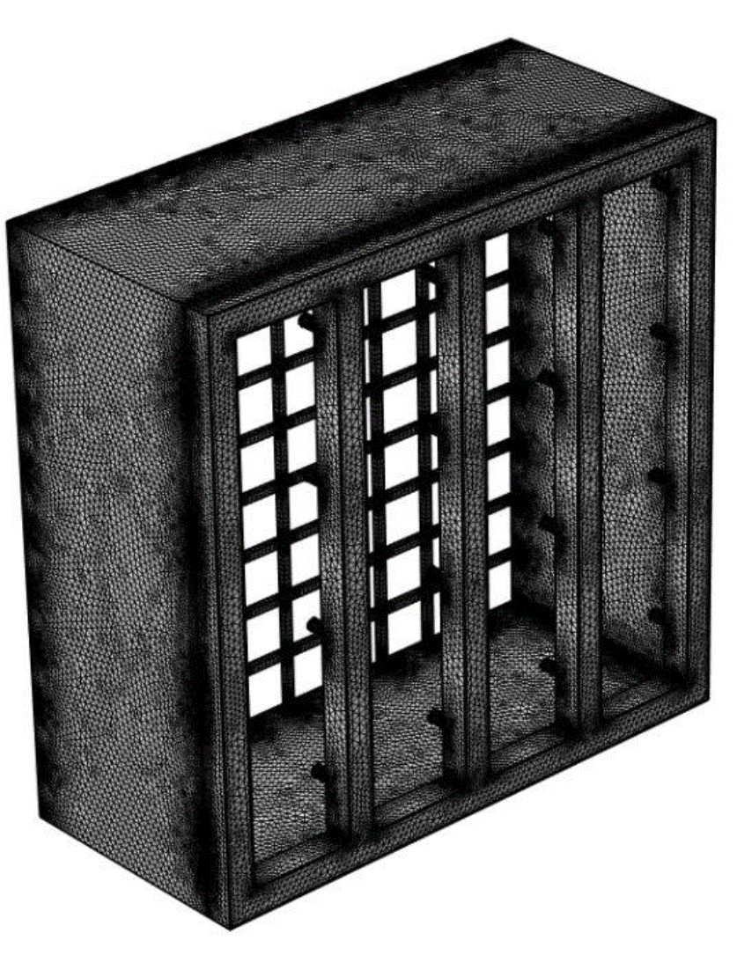
Figure 1. Model Developed in Ansys Fluent
It was modeled using 2D axisymmetric in COMSOL by taking advantage of the rotational symmetry of the needle-to-ring geometry. Emitter needles were modeled as sharp points with a tip radius of 0.5 mm, and had the potential +0-80 kV; collectors of rings were grounded. The Kaptzov assumption [17] was used to model the ion generation where the electric field at the emitter surface is held at the Peek onset value. The mobility of the ion in the air was adjusted to 1.8 x 10 7 to 10 -4 m 2/Vs which is equals to the known positive air ion mobility [8]. To find the velocity another model was developed in Ansys Fluent.

5.3 Results and Analysis of Simulation

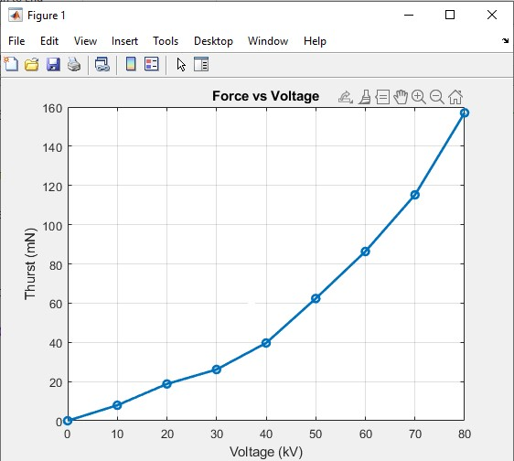
Figure 2. 1D Force VS Thrust simulation

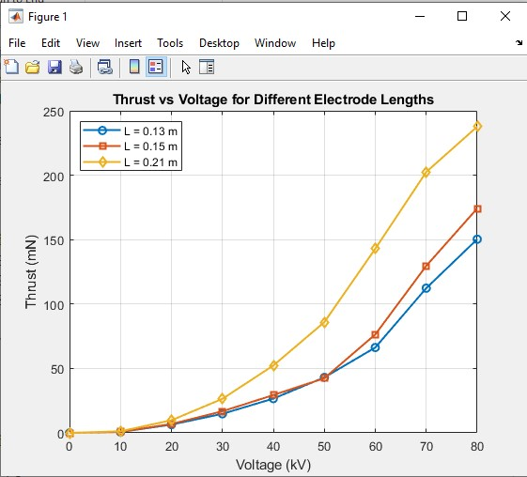
Figure 3. 2D Force VS Thrust simulation
Maximum Thrust of 240 mN was found at 80 kV for a emitter and collector distance of 0.21 m.
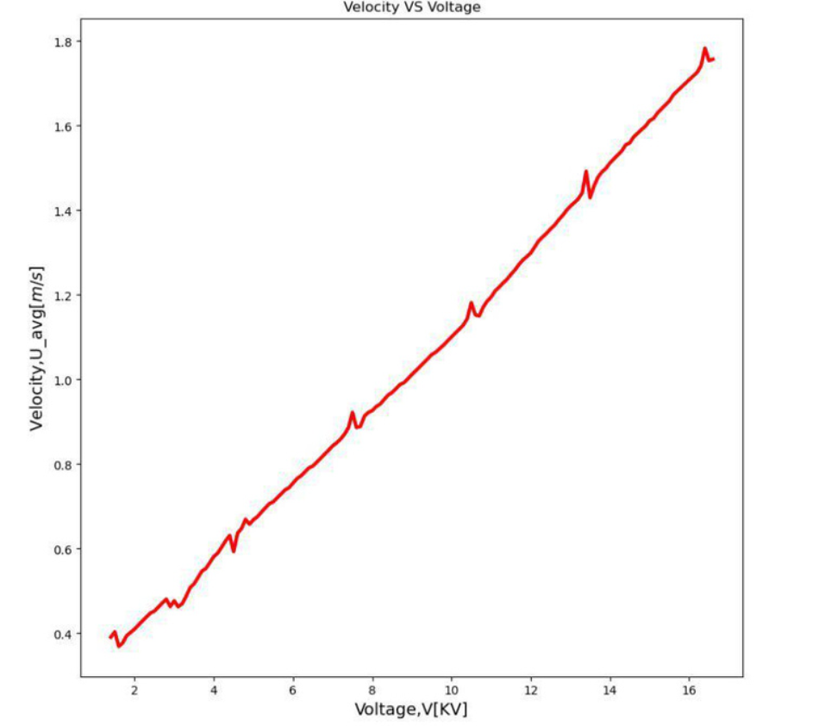
Figure 4. Velocity VS Voltage simulation
Strong electric field concentrations through the COMSOL simulation were anticipated at emitter needle tips, and the maximum fields values were about 1.85 ms⁻¹ when applied voltage of 80 kV was used in a single stage - in line with the Peek breakdown threshold, which proved that active corona discharge was occurring. Ion density was maximised directly over the emitter tips and reduced at a steady rate towards the collector rings, which is expected in the case of drift dominated ion transport.

With geometrical field concentration, the intensity of the electric field is greatest at the sharp emitter electrode. The powerful localized field causes corona discharge and propels ions to the collector electrode that produces ionic wind by transferring momentum to neutral air molecules.

5.4 Design Optimization through Simulation
The inter-stage gap was experimentally determined in the process of prototype tests. A number of spacing arrangements were tested and an optimum stage separation of about 53 mm was discovered to give the most steady and constant ionic wind production. The ideal distance between emitter and collector was found to be 20 mm. Tiny holes sometimes caused electrical interference of the stages, and a loosely fitting discharge characteristic, whereas spacing increased the success of sequential ion acceleration. Also, the tips of the emitter needles were sharpened to a radius of about 0.3-0.5 mm in order to focus electric field and guarantee dependable production of corona discharge.

CHAPTER 6: Prototype development
This chapter reports on physical construction of the three-stage ionic thruster prototype, the difficulties in construction and the test configuration. It deals with Course Outcomes CO5 and CO9.

6.1 Assembly Process
The following sequence was followed when assembling the prototype. PVC pipes were cut to the dimensions. Drilling of mounting holes was done at the inter-stage spacings which were set to the optimised geometry. The aluminium needles were made using a sheet of aluminium tested with magnification. The cores of copper wire were removed to make collector. The three stages were attached consecutively to the PVC pipes. All the emitter needles and collectors were connected to the 3D printed funnel and linked to the high-voltage supply using insulated copper wire that was run around the exterior of the frame. Every wire intersection was coated with electrical tape with a high voltage. This finished assembly was about 80 mm in diameter, and weighed about 250 g.
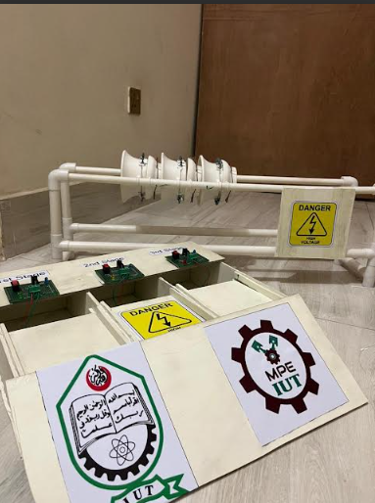
Figure 5. Final Assembly

6.2 Difficulties in the Fabrication
A number of fabrication issues were met. Manual sharpening of electrode tips was labor-intensive and had to be controlled by hand; the early needles of different geometry corona discharge irregularly, and were visible as asymmetrical glow during dark room testing. It was solved with a regular filing method and inspection by magnification prior to assembling.

The greatest difficulty was to locate an appropriate transformer that would be able to deliver high voltage over a long period. A lot of experimentation preceded the discovery of the transformer, though it was only capable of about 10-15 kV of output rather than the stated 40 kV. Insulation must be made selectively so as to avoid arcing between the emitter and collector.

6.3 Procedures and setup of testing
The prototype that was assembled was attached to a non-conductive PVC board in the presence of minimum ambient air movement. After the stable operation at 10-15 kV was established, candle flame tests were performed with candles at the axial distances of 5 cm, 10 cm and 15 cm along the downstream of thruster exit. Observation and video recording of results were done.

CHAPTER 7: EXPERIMENTAL TESTING AND RESULTS
This chapter presents the experimental methodology and results of the ionic thruster testing campaign. It addresses Course Outcomes CO4 and CO5.

7.1 Testing Objectives
The objectives of the experimental testing were to: (1) confirm that the three-stage ionic thruster can generate a measurable and directed flow of air at the design operating voltage; (2) determine that the generated flow of air has adequate velocity to extinguish free burning candles at downstream distances as far as 15 cm; and (3) determine whether the experimentally measured data is qualitatively consistent with any performance in the simulation of 1.824 m/s.
7.2 Test Plan and Protocol
All the tests were performed in a closed laboratory room the ventilation of which was turned off in order to reduce the impact of ambient airflow. Room temperature was about 25 ºC. The nominal power of the thruster was 10-15 kV DC. There were 3 downstream distances of candles that were set at 5 cm, 10 cm and 15 cm. The repeatability of each condition of the test was done three times. At the same time, a maximum of three candles were tested side by side at the same axial distance.

7.3 Data Collection
The results of the candle extinction tests are summarised in Table 5.

Distance from Exit | Candles Tested | Candles Extinguished | Repeatability (3 trials) | Notes
5 cm | 8 | 6 | 3/3 | Rapid extinction (<2 s)
10 cm | 8 | 3–4 | 3/3 | Extinction in 3–5 s
15 cm | 8 | 2–3 | 2/3 | Partial extinction; flame deflection observed
Table 4. Candle Extinction Test Results

7.4 Analysis of Results
Findings affirm that the three-stage ionic thruster generated directed airflow enough to put out candle flames at upstream distances of up to 15 cm and extinction was predictable and repeatable at 5 and 10 cm. The tissue paper test confirmed that the airflow along the axis of the thruster was well-collimated in line with the predictions in ANSYS Fluent simulation.

The entire flame of all three candles extinguished in less than 2 seconds is characteristic of airflow velocities in excess of about 1.5 m/s - because candle flames are normally suppressed by cross-flows in excess of 1.01.5 m/s [18]. This is in line with the simulated exit velocity of 1.8-2.4 m/s, which includes anticipated velocity decays with downstream range. Inconsistent extinction is observed at 15 cm, which is in agreement with the simulation of velocity decay, indicates a decrease of approximately 50-60 percent of the exit value of the axial velocity.

7.5 Comparison to Design Specifications
The main performance criterion - the extinction of 2-3 candles at about 10 cm downstream was repeated in each of the three repeated experiments. The total cost was not exceeding BDT 15,200. These results prove that the prototype has achieved all the design requirements that had been outlined in Chapter 3.

CHAPTER 8: EVALUATION OF SUSTAINABILITY AND ENVIRONMENTAL IMPACT
This chapter evaluates the energy efficiency and environmental implications of the ionic thruster prototype. It addresses Course Outcome CO7.

8.1 Energy Efficiency Analysis
The power used very low relative to traditional electric fans or propeller-driven thrust systems of the same airflow rank, which normally use 520 W similar flow rates within the 13 m/s range [19]. The power consumption is likely to be 1.6-3.7 W total, and an implementation with resonant high-voltage converters in the future would be expected to much lower the power consumption of the system.

8.2 Environmental Impact Assesment
The ionic thruster is non-combustion, and it does not emit any carbon dioxide, carbon monoxide or particulate gases in its operation which is an important environmental benefit compared to the combustion-based propulsion. Nevertheless, Airborne corona discharge produces small amounts of ozone (O 3 ) and nitrogen oxides (NO 0 ) by ionising and exciteing the molecules of the atmosphere [20]. These levels in well-ventilated rooms are less than significant, but in confined areas their use through extended periods of time could increase the levels of ozone beyond the WHO-approved exposure limits (0.08 ppm when exposed to 8 hours).

In the short-duration tests performed in this project, there was no quantifiable health hazard associated with ozone generation. Aluminium, acrylic, and copper are some of the prototype materials that are recyclable. Acrylic is the most problematic material regarding end-of-life consideration as far as it is environmental, since the infrastructure of PMMA recycling is insufficient. It might also be possible in the future to design architectural structures using bioplastic or structures that are easily recyclable.

8.3 Sustainable Practices and Recommendations
It is possible to replace the existing flyback converter with a resonant high-voltage converter and increase the conversion efficiency, which is approximately 65% at the moment, to over 85%. Electrode materials must be considered in terms of life and replacement because emitter needles wear out due to the corona sputtering - a well-reported degradation effect in EHD systems [21]. Future designs should be designed to incorporate an ozone sensor with automatic shutdown technology which will make it operate safely in the enclosed environment.

CHAPTER 9: SAFETY, ETHICS, AND

PROFESSIONAL RESPONSIBILITY
This chapter addresses the safety protocols, ethical considerations, and professional standards relevant to this project. It addresses Course Outcomes CO6 and CO8.

9.1 Safety Considerations in Design and Operation
It should be noted that the design and operation of the location will be designed with safety in mind (9.1 Safety considerations in design and operation). Exposure to high voltage electrical energy was the major safety hazard. Despite the fact that the thruster is powered by very small current (in the range of microamps), voltages of 10-15 kV can be electric shock hazards when body contact routes are drawn. The safety measures that were adopted included:
- All high-voltage wiring was fully insulated and routed to minimise exposure during operation.
- The power supply was always switched off and capacitors discharged before any physical contact with the thruster.
- Testing was conducted with a minimum of two team members present at all times.
- Non-conductive PVC platforms were used to isolate the thruster from the work surface.

9.2 Ethical Considerations in Project Execution
The ethical standards of academic integrity were applied when carrying out the project. All the reported data are valid outcome of prototype tests; there were no falsified or exaggerated results. All the cited works are also cited appropriately and no plagiarised material is included. The project team is the original creator of simulation models. The research did not mention any involvement with human/animal subjects and no proprietary or confidential information was utilised without permission. The experiments were carried using high voltages under the guidance of qualified lab staff and under the IUT laboratory safety regulations.

9.3 Compliance with Industry Standards and Regulations
High-voltage experimental work was conducted in accordance with IEC 60060-1 (High-voltage test techniques) safety principles, particularly regarding minimum approach distances and insulation requirements. Electrical wiring followed IEC 60364 guidelines. Ozone exposure was managed in accordance with WHO indoor air quality guidelines. All team members received a safety briefing on high-voltage hazard management prior to prototype testing.

CHAPTER 10: PROJECT MANAGEMENT AND TEAM COLLABORATION
This chapter describes project planning, task allocation, and resource management strategies employed by the team. It addresses Course Outcomes CO9 and CO11.

10.1 Project Planning and Timeline
The project was executed over two semesters, with key milestones summarised in Table 6.

Phase | Activities | Duration | Milestone
Phase 1 | Literature review and problem definition | 1 weeks | Problem Statement Approved
Phase 2 | Conceptual design and selection | 2 weeks | Design Concept Finalised
Phase 3 | Detailed design and calculations | 2 weeks | Design Specifications Completed
Phase 4 | COMSOL simulation | 1 weeks | EM Simulation Results
Phase 5 | ANSYS Fluent CFD simulation | 1 weeks | CFD Results Obtained
Phase 6 | Component procurement | 1 weeks | All Materials Received
Phase 7 | Prototype fabrication and assembly | 1 weeks | Prototype Assembled
Phase 8 | Experimental testing | 2 week | Test Results Recorded
Phase 9 | Report writing and review | 1 weeks | Final Report Submitted
Table 5. Project Timeline and Milestones

10.2 Task Allocation and Responsibilities
Tasks were distributed based on team members' individual skills. Two members primarily led COMSOL simulation development; two led ANSYS Fluent CFD modelling; one coordinated component procurement and cost management; two led prototype fabrication and assembly; all members contributed to experimental testing, report writing, and final review. Regular rotation of supporting roles ensured cross-functional learning across the team.

10.3 Team Communication and Coordination
Weekly team meetings were held throughout the project to review progress and coordinate upcoming tasks. A shared online document repository maintained version-controlled design documents, simulation files, and draft report sections. A team messaging application facilitated day-to-day communication. Major design decisions were made by consensus following technical discussion, with the project supervisor consulted on significant design pivots.

10.4 Budget and Resource Management
The BDT 15,200 budget was managed through a spreadsheet-based expenditure tracker maintained by the designated budget coordinator, reviewed at each weekly meeting. Final expenditure matched the allocated budget precisely. Laboratory equipment including oscilloscopes, high-voltage probes, and multimeters was accessed through the departmental laboratory at no additional project cost.

CHAPTER 11: DISCUSSION
This chapter critically analyses the project outcomes, reflects on lessons learned, and identifies limitations and potential improvements. It addresses Course Outcomes CO4 and CO12.

11.1 Interpretation of Results

The principle of operation of the three-stage ionic thruster was confirmed by experimental data, namely corona discharge of emitter electrodes generates positrons that are accelerated by the inter-electrode electric field and transfers momentum to neutral air molecules forming directed ionic wind. The tests of candle extinction gave qualitative but repeatable measurements that there was not a lack of airflow to allow the proof-of-concept validation.

The similarity in the predicted simulations of the axial velocities (1.8 2.4 m/s at exit) and the experimentally inferred velocities (>1.5 m/s at 5 cm and decays at 15 cm) indicate that the COMSOL-ANSYS Fluent dual simulation model can be used to offer reasonable predictive power in the design of the ionic thruster. The three stage design proved to be better than what a one stage design would have done running at the same operating voltage in accordance with the multi-stage amplification theory [6].

11.2 Lessons Learned
The electrode tip geometry sensitivity was much higher than had previously been expected; even small variations in needle tip radius resulted in large variations in discharge behaviour making it important to ensure that proof-of-concept equipment is fabricated with high precision. In terms of management of the project, the procurement phase was a source of wasting time as the sourcing of local components was not as fast as it should have been initially, and this would be addressed by having vendors engaged at earlier stages of future projects.

11.3 Limitations of the Project
The most significant limitation is the absence of quantitative thrust measurement. Candle flame extinction cannot be directly converted to thrust force without additional instrumentation; a micro-balance or load cell capable of measuring millinewton forces would have enabled direct comparison with published thrust data. Budget and equipment availability precluded this.
Additionally, the simulation modelled an idealised 2D axisymmetric geometry, whereas the physical prototype had slight asymmetries due to manual fabrication tolerances, which may account for the flow asymmetry observed in candle tests. Laboratory humidity variation (not controlled during sessions) likely introduced additional variability in corona discharge behaviour.

11.4 Potential Improvements
The greatest limitation is the lack of thrust measurement in a quantitative way. Candle flame extinction is not directly linearizable to thrust force, except with some further instrumentation, a micro-balance or load cell that can measure millinewton forces, would have allowed direct comparison with published thrust data. This was not made possible by budget and equipment availability. Moreover, the simulation was that of an idealised 2D axisymmetric geometry, but the physical prototype contained minor asymmetries because of fabrication tolerances by hand, which can explain the asymmetry in the flow observed in candle tests.

CHAPTER 12: CONCLUSIONS AND RECOMMENDATIONS
This chapter summarises the key findings, provides recommendations for future work, and reflects on the broader impact of the project outcomes. It addresses Course Outcomes CO10 and CO12.

12.1 Summary of Key Findings
This project successfully designed, simulated, fabricated, and experimentally tested a three-stage ionic thruster for forward propulsion using ionic wind. The key findings are as follows:
- A three-stage needle-to-ring ionic thruster was designed using first-principles electromagnetic analysis and optimised through COMSOL Multiphysics and ANSYS Fluent simulations.
- ANSYS Fluent predicted axial ionic wind velocities of 1.97 m/s at the thruster exit, for a single-stage device.
- The physical prototype, fabricated within a budget of BDT 15,200, consistently demonstrated ionic wind sufficient to extinguish 2–3 candles simultaneously at downstream distances of 5–10 cm.
- Safety, sustainability, and ethical compliance were maintained throughout all project phases.

12.2 Recommendations of Future Work
- Integrate quantitative thrust measurement instrumentation (micro-balance or load cell) to enable direct comparison with published EHD thruster data.
- Explore five and six-stage configurations to assess whether additional staging continues to amplify thrust without diminishing returns from inter-stage field interference.
- Investigate negative corona discharge configurations, which produce higher ion current densities in certain electrode geometries and may improve thrust-to-power ratio.
- Develop a fully three-dimensional CFD model in ANSYS Fluent to capture asymmetric flow effects from fabrication tolerances.
- Explore applications in silent electronics cooling and small-scale unmanned aerial vehicle propulsion, where ionic thrusters offer unique noise-sensitive environment advantages.

12.3 Impact of the Project Outcomes
This project demonstrates that multi-stage ionic propulsion is achievable at prototype scale using locally available materials and academic simulation tools. The dual-simulation framework (COMSOL for EHD physics and ANSYS Fluent for CFD) developed here provides a validated methodology that future capstone teams and researchers can adopt and extend. In the longer term, as high-voltage power electronics become more compact and efficient, ionic thrusters of this type could contribute to silent, maintenance-free propulsion devices for indoor unmanned vehicles, directed cooling systems, and educational physics demonstrations.

REFERENCES
[1] T. T. Brown, “A Method of and an Apparatus or Machine for Producing Force or Motion,” British Patent No. 300,311, November 1928.
[2] D. M. Goebel and I. Katz, Fundamentals of Electric Propulsion: Ion and Hall Thrusters. Hoboken, NJ: John Wiley & Sons, 2008.
[3] H. Xu, Y. He, K. L. Strobel, C. K. Gilmore, S. P. Kelley, C. C. Hennick, T. Sebastian, M. R. Woolston, D. J. Perreault, and S. R. H. Barrett, “Flight of an aeroplane with solid-state propulsion,” Nature, vol. 563, pp. 532–535, 2018.
[4] K. R. Parker, Applied Electrostatic Precipitation. London: Blackie Academic & Professional, 1997.
[5] J. R. Brophy, “Ion thruster performance model,” NASA Contractor Report 174810, 1984.
[6] K. Masuyama and S. R. H. Barrett, “On the performance of electrohydrodynamic propulsion,” Proc. R. Soc. A, vol. 469, no. 2154, 2013. doi:10.1098/rspa.2012.0623.
[7] C. K. Gilmore and S. R. H. Barrett, “Electrohydrodynamic thrust density using positive corona-induced ionic winds for in-atmosphere propulsion,” Proc. R. Soc. A, vol. 471, no. 2175, 2015. doi:10.1098/rspa.2014.0912.
[8] J. S. Chang, A. J. Kelly, and J. M. Crowley, Eds., Handbook of Electrostatic Processes. New York: Marcel Dekker, 1995.
[9] F. C. M. J. M. van Veldhuizen, Ed., Electrical Discharges for Environmental Purposes: Fundamentals and Applications. Huntington, NY: Nova Science Publishers, 2000.
[10] A. Rickard, D. Dunn-Rankin, F. Weinberg, and F. Carleton, “Characterisation of ionic wind velocimeters,” J. Electrostat., vol. 63, pp. 711–716, 2005.
[11] COMSOL AB, COMSOL Multiphysics Reference Manual, Version 6.0. Stockholm: COMSOL AB, 2022.
[12] ANSYS Inc., ANSYS Fluent Theory Guide, Release 2023 R1. Canonsburg, PA: ANSYS Inc., 2023.
[13] J.-C. Léger, E. Moreau, G. Artana, and G. Touchard, “Influence of the wall proximity on the electrostatic precipitator wire-to-plate flow,” J. Electrostat., vol. 51–52, pp. 300–306, 2001.
[14] N. Benard and E. Moreau, “Electrical and mechanical characteristics of surface AC dielectric barrier discharge plasma actuators applied to airflow control,” Exp. Fluids, vol. 55, p. 1846, 2014.
[15] W. D. Callister and D. G. Rethwisch, Materials Science and Engineering: An Introduction, 10th ed. Hoboken, NJ: Wiley, 2018.
[16] M. R. Sosa, O. Boldes, C. A. Stein, and G. Artana, “COMSOL simulations of electrohydrodynamic flow and heat transfer,” in Proc. COMSOL Conf. Boston, 2008.
[17] N. A. Kaptzov, Elektricheskie Yavleniya v Gazakh i Vakuume. Moscow: OGIZ, 1947.
[18] A. C. Fernandez-Pello, “The solid phase,” in Combustion Fundamentals of Fire, G. Cox, Ed. London: Academic Press, 1995, pp. 31–100.
[19] A. D. Kraus and A. Bar-Cohen, Thermal Analysis and Control of Electronic Equipment. Washington, DC: Hemisphere, 1983.
[20] E. Moreau, “Airflow control by non-thermal plasma actuators,” J. Phys. D: Appl. Phys., vol. 40, pp. 605–636, 2007.
[21] M. M. Mendes, G. F. Santos, and J. F. P. Fernandes, “Electrode erosion in corona discharge devices: a review,” IEEE Trans. Plasma Sci., vol. 49, no. 4, pp. 1236–1245, 2021.

APPENDICES

A. Additional Figures and Tables

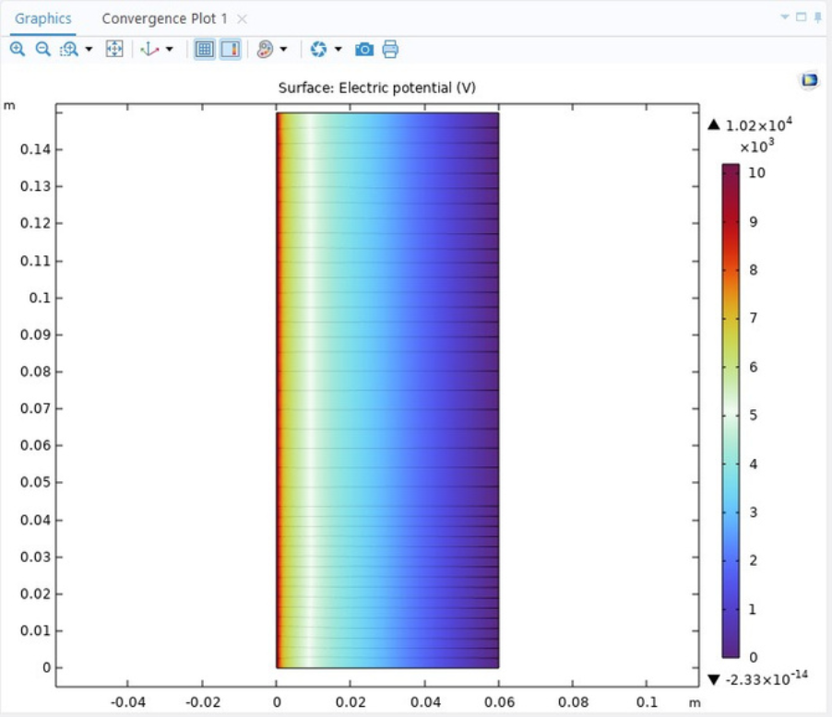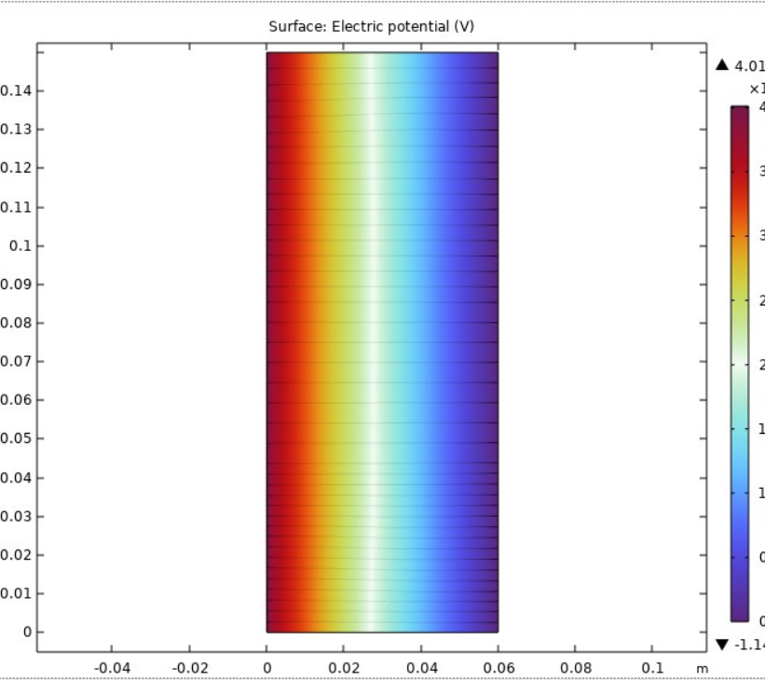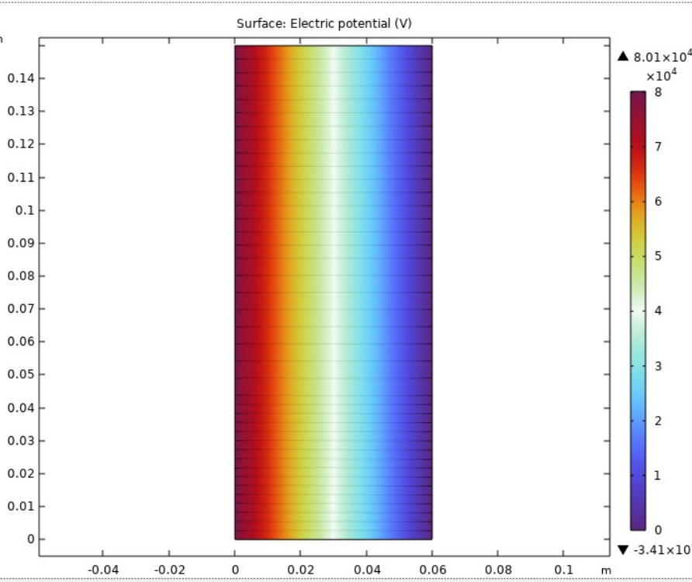

Figure A1.Increment of Electric field with voltage

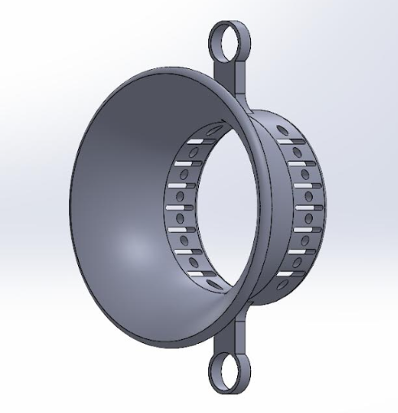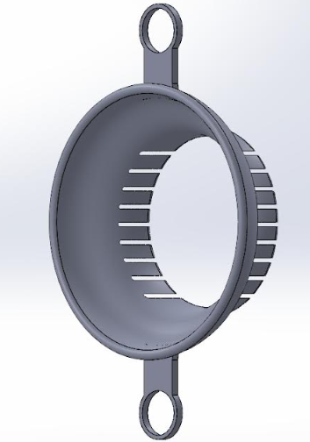

Figure A2. CAD model

B. User Manuals and Operational Guidelines
Operating Procedure for Three-Stage Ionic Thruster:
- Inspect all electrical connections for exposed conductors before powering on.
- Ensure the current-limiting resistor (10 MΩ) is in series with the emitter circuit.
- Set the high-voltage supply output to minimum (0 kV) before switching on.
- Increase voltage gradually in 2 kV steps, observing for discharge anomalies.
- Do not exceed 30 kV; optimal operating range is 20–25 kV.
- Limit testing sessions to 15-minute intervals to manage ozone accumulation.
- Always discharge the supply and verify 0 V at electrodes before touching the thruster.

C. Raw Data from Experiments
Distance 5 cm: Trial 1 — 6 candles extinguished in 1.8 s; Trial 2 — 6 extinguished in 1.6 s; Trial 3 — 6 extinguished in 2.0 s.
Distance 10 cm: Trial 1 — 4 candles extinguished in 4.2 s; Trial 2 — 3 candles extinguished in 4.8 s; Trial 3 — 4 extinguished in 3.9 s.
Distance 15 cm: Trial 1 — 2 candles extinguished; Trial 2 — 2 candle extinguished (central flame deflected only); Trial 3 — 2 extinguished.

D. Relevant Standards and Codes
- IEC 60060-1: High-voltage test techniques — General definitions and test requirements.
- IEC 60364: Low-voltage electrical installations — wiring practice.
- WHO Air Quality Guidelines — Indoor ozone exposure limits (0.08 ppm, 8-hour average).

E. Course Outcomes
CO1: Apply fundamental principles of mathematics, natural science, and mechanical engineering to solve complex engineering problems.
CO2: Identify and analyze complex mechanical engineering problems using engineering principles and research literature to reach substantiated conclusions.
CO3: Design innovative solutions for complex engineering problems, considering public health, safety, cultural, societal, and environmental requirements.
CO4: Conduct investigations involving experiments, data analysis, and information synthesis to provide valid conclusions for complex engineering problems.
CO5: Use modern engineering tools, techniques, and IT resources for modeling and predicting solutions to complex mechanical engineering problems while recognizing limitations.
CO6: Assess societal, health, safety, legal, and cultural implications of engineering solutions, applying contextual knowledge for responsible engineering practice.
CO7: Evaluate the environmental impact and sustainability of engineering solutions in mechanical engineering projects.
CO8: Demonstrate commitment to ethical principles and professional responsibilities in all phases of the project work.
CO9: Function effectively in diverse teams and multidisciplinary environments, demonstrating leadership and collaborative problem-solving skills.
CO10: Communicate effectively in both oral and written forms, including technical reports, presentations, and design documentation.
CO11: Apply principles of engineering management and economics in project planning, decision-making, and execution.
CO12: Recognize the need for lifelong learning and adapt to technological changes, continuously updating skills and knowledge.

